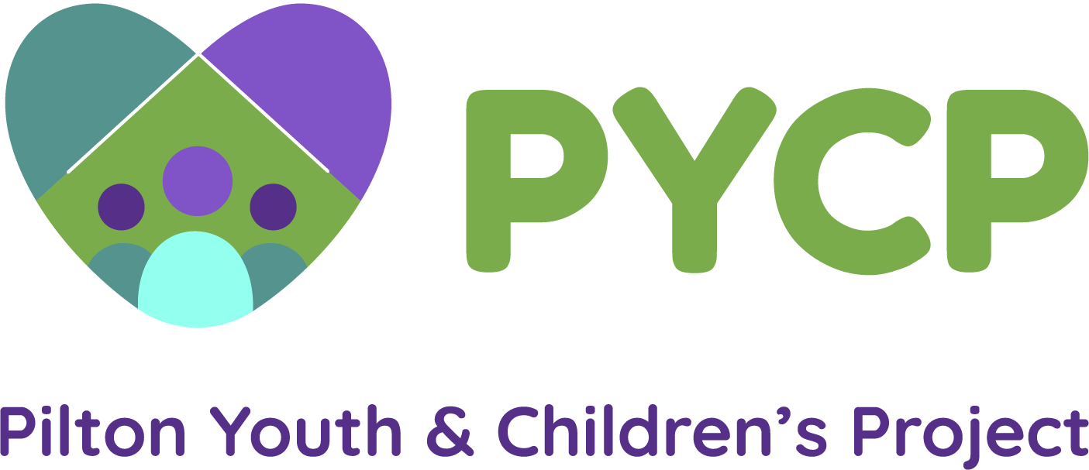
Volunteer Application Form

Name:

Address:

Tel:

Email:
Why are you interested in volunteering at Pilton Youth & Children’s Project?

How did you hear about Pilton Youth & Children’s Project?

Can you tell us about an adventure you’ve had? (or you’d like to have!)

Can you tell us about your work or voluntary experience so far?

What do you hope to gain from volunteering?

Do you have any particular skills/interests that you would like to share with children and young people?

Please supply the names and contact details of 2 people who we can contact for references:

Name: Name:

Email: Email:

Relationship: Relationship:

Due to the nature of our work we are obliged to ask all potential workers and volunteers to complete a Disclosure Scotland.

Disclosure of convictions does not necessarily prevent a person from volunteering for PYCP. Any information will be treated confidentially.

If you have any previous criminal convictions can you please indicate here: YES/NO

Signed:

Date:

Thank you for completing this application.

Please return to:

Lesley Ross
Pilton Youth & Children’s Project
The Greenhouse
33 West Pilton Brae
Edinburgh
EH4 4BH

Email: lesley@pycp.co.uk

Web: www.pycp.co.uk

Tel: 0131 332 9815

Fax: 0131 538 7887

